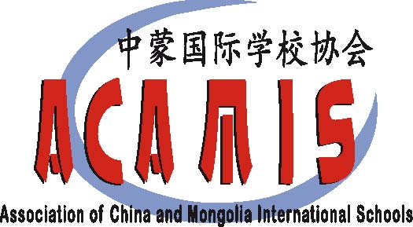 | TEACHER PRESENTATION PROPOSAL FORM  15th Annual ACAMIS Chinese Conference | June 30 – July 2, 2017  at Utahloy International School  of Guangzhou

Dear colleagues, we need your support!

Presenting at the ACAMIS Chinese Conference is a great way to share your knowledge and expertise with your fellow teachers. It is also an excellent opportunity for networking. You are warmly invited to join us for ‘A Day of Sharing’ at the coming ACAMIS Chinese Conference on the third day (July 2, 2017).

There are two sessions on July 2 that will be allocated for teachers to provide their sharing. You can choose to do either one or both if you like. If you plan to do two sessions, you may present one topic and repeat that on the second session, or present two different topics.

The following areas are possible topics for your consideration:
- Teaching literacy skills: strategies and teaching materials
- Effective teaching strategies/methods
- Using technology to teach Chinese language and culture
- Curriculum design and implementation
- Assessment for learning
- The way to integrate language with culture
- Classroom management
- IB PYP, MYP and DP in Chinese
- Other topics

Presentation language: Mandarin Chinese
Each presentation Session Time: 60 minutes
Please send the Teacher Presentation Proposal Form to eo@acamis.org by May 31st, 2017. Confirmation shall reach you by early June.

NOTES:

- Your proposal should be approved by the Head of Department (or Chinese Coordinator) and Head of School.
- The presentation should be rehearsed among departmental colleagues for quality assurance.
- I agree to provide presentation materials (for example the PowerPoint slides) to participants.
- A Token Gift of RMB 300 shall be given to each presentation given.

We look forward to receiving your proposal!

 | TEACHER PRESENTATION PROPOSAL FORM  15th Annual ACAMIS Chinese Conference | June 30 – July 2, 2017  at Utahloy International School  of Guangzhou

Instructions:
1: Please complete the form in Chinese or English.
2: Please email to eo@acamis.org your short biography (in Chinese) and a high-resolution photo (head and shoulder shot).
3: Please return the form, biography, and photo to eo@acamis.org by May 31, 2017.
4: The contents of this form (from ‘Presentation Title’ to ‘Target Audience’) will be posted on the website and on the Guidebook app that will be seen by participants.

Name of Presenter(s): __________________________________________________

School Name: _________________________________________________________

Number of Sessions you will be presenting (1 session or 2 sessions, each session 60 minutes): ____

Presentation Title #1: _______________________________________________________

Description (Summary about your presentation, within 100 words):

Keywords and phrases (a list of key terms in your presentation):

Practical Implementation (Bullet point practical implementation in classroom, maximum 10):

Target Audience (specify – target age groups/grade level, language proficiency level):

Comments: for CLTN committee used only (The suitability of the topic/presentation method/practical significance)

 | TEACHER PRESENTATION PROPOSAL FORM  15th Annual ACAMIS Chinese Conference  THEME? | June 30 – July 2, 2017  at Utahloy International School  of Guangzhou

Presentation Title #2 (if applicable): ________________________________________________

Description (Summary about your presentation, within 100 words):

Keywords and phrases (a list of key terms in your presentation):

Practical Implementation (Bullet point practical implementation in classroom, maximum 10):

Target Audience (specify – target age groups/grade level, language proficiency level):

Confirmation:

I _________________________(name) hereby certify that my Head of Department and Head of School have approved this presentation. The presentation will be rehearsed in my department prior to the conference to guarantee its quality. I confirm that I will make my presentation materials (like PowerPoint slides) available to the participants.

Comments: for CLTN committee used only (The suitability of the topic/presentation method/practical significance)

