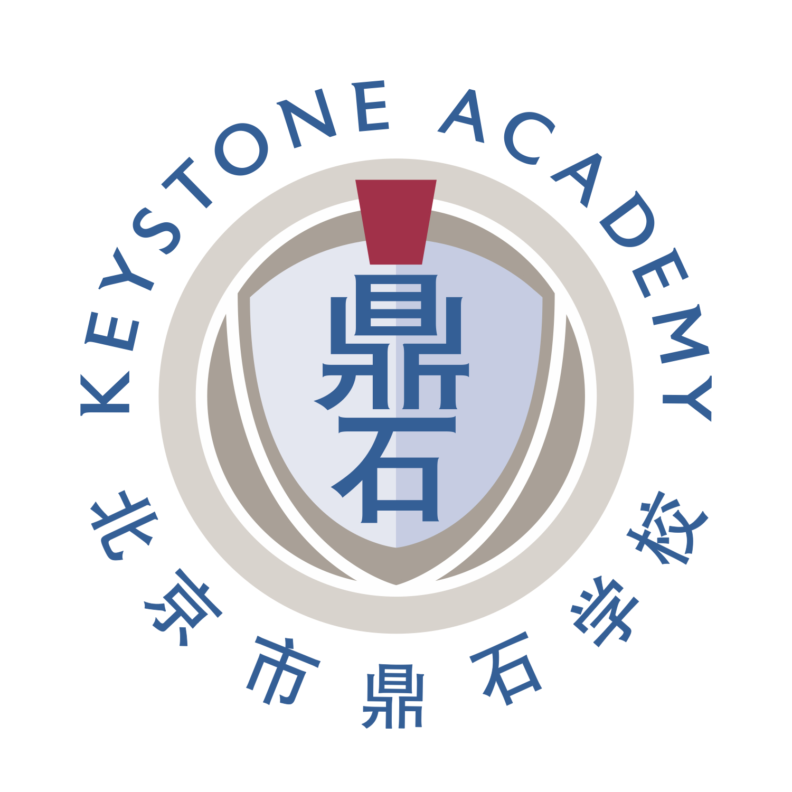

ACAMIS Spring Leadership Conference
March 6 -7, 2020 at Keystone Academy, Beijing
Theme: “Values Added”
Peer Presenter Proposal Form

This year the theme of the annual ACAMIS Spring Leadership Conference will be “Values Added”. In many schools, we think about “Value Added”. Usually this refers to what the institution, and teachers, add to what the students bring with them. We expect creative and productive schools like ours to add significant value to our students’ learning. Perhaps not quite so many schools concern themselves with the ‘values’ that they add to the lives of their students. Our theme of “Values Added” is meant to encourage engagement with and discussion of the importance of values in the school curriculum, in and out of the classroom. Is it enough to be merely a “Value Adding” school? Or does holistic learning, which might encompass character and moral growth in addition to scholastic development, require “Values Added” as well?

This year’s theme recognizes that learning communities grow in goodness together. We are rigorous academic institutions at all levels, of course, but as schools we should be looking for, and looking after, so much more than the pursuit of the intellectual. At Keystone, the centrality of our 5 values – arising as they do from the Confucian tradition -- is part and parcel of our public purpose: We believe that China, and the world, need students and teachers who bring the life of the mind together with a caretaker’s spirit. As educators, we set our sights on the development of character and community throughout our school setting, and beyond.

The conference in March, our annual getting together, will provide many opportunities to demonstrate and explore “Values Added”: what this means in theory; how to do it in practice; and what a difference successful and committed applications of values make to the lives of our students, ourselves, and our institutions.

Possible topics for discussion in each strand might include the following:
Leadership and values
The teacher/adult as a role model
Community service as an exemplary builder of values
Implicit and explicit paths to values added
Moral education local and global
Assessing the growth of character in community
Advising/tutoring and values added
Adding values to curricular initiatives in personal development
Issues of importance to member schools

We are looking for presenters to share their ideas and strategies with various leadership groups at our conference. Please come and share your successes, failures and stories in your area of expertise. Giving voice, choice and ownership to staff and to students is critical to their determination of how they learn and achieve their goals. If you have tried different strategies in your school, come share them with your colleagues.

Peer presentations are welcomed for each of the eight strands of the conference, which are:
- Heads, Principals
- Middle Management and Aspiring Leaders
- Business Managers, HR
- Athletic Directors
- ACE & Performing Arts Coordinators
- Community Learning and Service
- Residential Life & Pastoral Care
- University Placement Counselors/Advisors
- Library

Presentations session should take no longer than 60 minutes. We will review all proposals in each of the 8 strand areas. You will be informed by the strand leader of workshop selections by early December.

If you would like to submit more than one proposal, please submit a separate proposal form. Only a short description of the proposal is required. If accepted, you will have time from December to March to develop the presentation.

Deadline for Proposal Submissions
Please send the Presentation Proposal Form to Uma Lian at peerproposals@keystoneacademy.cn by Friday, November 1, 2019. Notification of the decision on selection shall reach you in early December 2019. Upon confirmation of approval, we will follow up with registration where approved peer presenters will enjoy a reduced rate of US$260.

NOTES:
- Your proposal must be approved by the relevant authority in your school
- The presentation should preferably be rehearsed among departmental colleagues for quality assurance.
- You agree to provide soft copies of presentation materials (for example the PowerPoint slides) to participants.
- Presenters selected will receive a 25% discount on the conference registration fee.
- If your proposal is approved by the committee, the contents of this form will be posted on the ACAMIS website and on the Guidebook app that will be seen by participants.

Thank you, in advance, for stepping up to this challenge!
We look forward to receiving your proposal!

(Please scroll further down to the Proposal Form)

2020 ACAMIS Spring Leadership Conference
Peer Presentation Proposal Form

Please place photo here
or send a higher resolution file separately

Name:
Email Address:
School Name:
Role/Position:
A short profile/bio/description about yourself (no more than 100 words):
Presentation Title:
Strand Presenting to:  Please BOLD/HIGHLIGHTED the appropriate strand(s) | - Heads, Principals  - Middle Management and Aspiring Leaders  - Business Managers, et al  - Athletic Directors  - ACE & Performing Arts Coordinators  - Community Learning and Service  - Residential Life & Pastoral Care  - University Placement Counselors/Advisors  - Library
Short description of your workshop proposal:
How will your workshop connect to our theme?
Target Audience(s):
Who will benefit from your presentation?
(e.g. Target age groups/grade level and language proficiency level):
What would be the ‘take-away’ for the audience?
What would you require for your presentation?
Please answer the following:
- Powerpoint format - for Windows or Mac?
- Do you need Audio/Video set up?
- Do you need stationery (markers, chart papers, etc.)? Please specify.
- Please specify other classroom set up needs if any.
(e.g. classroom set up/space, Technical needs/setup, etc.)

By November 1, submit Proposal Form to: peerproposals@keystoneacademy.cn

Thank you for your submission. We will contact you with our decision.

