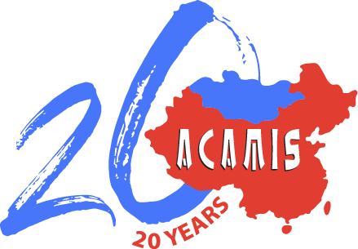

The Jim Koerschen Award for Innovation in Schools

The Koerschen Award for Innovation in Schools was created by the Board of Directors of ACAMIS in honour of Dr. Jim Koerschen. Jim, or Dr. K as he was affectionately called by all who knew him, was a former university President and an esteemed international educator during his five years as Head of School at Concordia International School Shanghai. He served on the ACAMIS Board for three years and in 2013, was appointed and served as the first Executive Director of ACAMIS until he passed away in 2014.

He became known within ACAMIS as an innovative educator and outside-the-box thinker. It is with this in mind that the Award for Innovation in International Schools was created. Participation in the Award is open to students enrolled in all ACAMIS full membership schools in China and Mongolia.

The Koerschen Award is meant to provide a means of encouraging or stimulating innovation within schools as participants:
- apply academic, social and personal skills to create an innovative program, system, activity or service for their school community;
- work within groups to apply creativity to achieve authentic outcomes;
- gain a deeper understanding of themselves, their community, and their school;
- demonstrate leadership while guiding a team to solve problems and work collaboratively while helping others.

Award
Up to USD 2,500 may be awarded to the successful applicant team as determined by the ACAMIS Selection Committee named by the ACAMIS Board.

Who Should Apply?
The Koerschen Award is open to students who are enrolled in ACAMIS member schools in the full membership category and are supported by the Head of School and a faculty representative who provides guidance to the group carrying out the innovation.

Application Process
Application must be made using the ACAMIS Koerschen Award Application Form that can be downloaded from the website when the application period begins. The proposal should be no more than 750 words.

For this award, there may be multiple applicants within one school, in which case, the school should select the best entry and submit only one application per school.

All sections of the Koerschen Award Application Form need to be completed and may include supplementary and supporting information.

When completing the Innovation Award Proposal the applicant(s) should consider the following questions:
- What kind of innovation is being planned?
- Why is the innovation meaningful to the school?
- Why is this project important to the innovators?
- What outcomes has the innovation provided fellow students and/or the school?
- How can success of the innovation be measured or described?

Application Deadline
The completed ACAMIS Koerschen Award for Innovation Application Form must be sent to the ACAMIS Executive Officer at eo@acamis.org no later than February 14, 2021 for the current school year. Late applications will not be accepted.

KOERSCHEN AWARD FOR INNOVATION
Application Form

School Year of Application, ie 2019-2020.

Name of School:

Address of School

Names of student team members submitting application form (If more than six, please add, if fewer, leave blank)
1.
2.
3.
4.
5.
6.

Name and Email address of student team leader submitting application form:

Name and email address of teacher supervising the Innovation Project:

HEAD OF SCHOOL DECLARATION
I understand and approve of the project being submitted for the ACAMIS Koerschen Award for Innovation:

Head of School Name and email address:

Head of School Signature:

Date

Please continue to next page

The student group members must complete each of the following sections in addressing each of the accompanying criteria provided as a guide. You may wish to attach additional information (charts, photos, etc) in support of your project. However, this Award application should not exceed 750 words.

Project Title:

Proposed Innovation:

Feasibility Plan:

Action Steps:

Desired Outcome:

Describe how the Award will be used to Support the Project:

Please contain the writing within each text box, but feel free to extend to an additional page to reach 750 words.

---------------------------------------------------------------------------------------------------------------------
Additional Page (if necessary):

