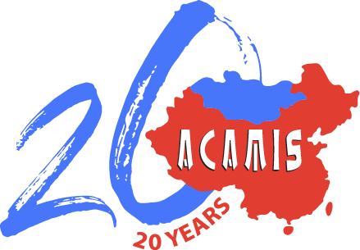
Jim Koerschen Award Proposal
Preliminary Notice Form

The Koerschen Award for Innovation in Schools may mesh well with CAS or other forms of student leadership within your school. The ACAMIS Board has established one award of US$ 2500 which is meant to provide funding specifically for the selected project. The one project selected will be announced at the Opening Session of the Spring Conference each year.

This preliminary notice form is important for ACAMIS to know which schools plan to participate. The actual proposal will be evaluated on the merit of the concept. This means that a proposed project need not already be in place, but can be implemented after submission of the proposal when the outcome of the Award is known. Projects that are already underway are also eligible for consideration. The best projects are those that are sustainable over time by other students moving up in school. As it can take up to two years for a project to start, a project is best proposed by students in grades 9-11 or years 10-12. File the preliminary application as soon as possible and when the proposal is ready, submit the online application

Name of ACAMIS Member School

Print Name of Teacher Sponsor or Organizer Email address of sponsor or organizer

These projects serve as examples of previously funded Koerschen Awards in its first two years and are not meant to be categories or suggestions for your group.

2017: Beijing City International School: A team of four BCIS Students dedicated themselves to
creating a free platform for high school students to access professional hands‐on business
education and to connect with successful entrepreneurs, experienced investors and business
experts. Their goal was to create a vigorous, self-sustaining network for young entrepreneurs, innovators, and business mentors that others can draw upon for advice. The award money was used to promote the project within ACAMIS and in East Asia.

2016: Concordia International School: Concordia’s social entrepreneurship class started their social enterprise entitled Third Culture Coffee Roasters. Sixteen students obtained first-hand business experience by purchasing green coffee beans directly from farmers in Yunnan, China, roast them on campus, and sell the roasted coffee to the Concordia community on behalf of the Yunnan coffee growers to help alleviate poverty among the growers in Yunnan and contribute to the social needs of that community. The award money was used to purchase a coffee roaster to make the project self-sufficient and sustainable.

