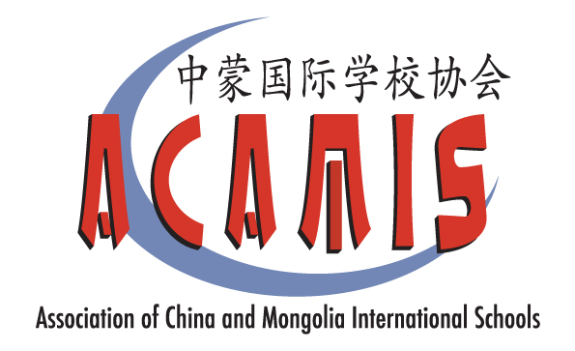

2019 ACAMIS Chinese Conference
June 29-30, 2019
Yew Chung International School of Shanghai – Ronghua Campus
Theme: Learning Chinese Should be Fun: Methods to Enhance Learning
知之，乐之！

Presenting at the ACAMIS Chinese Conference is a great way to share your knowledge and expertise with your fellow teachers. It is also an excellent opportunity for networking.

This year’s ACAMIS Chinese conference is going to focus on methods to enhance the fun and joy experience of learning and teaching Chinese. We believe that learning should be fun and we hope our peers and students can enjoy and experience the joy of learning and teaching Chinese.

We are looking for teachers with ideas and strategies to share at our conference. If you already practice good collaboration with a teacher, you can come and present together. If you have tried different strategies in the classroom that have been successful, come share them with your colleagues.

We are looking for strategies takeaways that are relevant to the theme. We welcome teacher presenter teams to share their expertise with our peers. Possible examples might include (but are not limited to):
- Effective teaching strategies/methods
- Using technology to teach Chinese language and culture
- Curriculum design and implementation
- Assessment for learning
- Integrating language with culture
- Classroom management
- Other pedagogies such as:
  - Mother-tongue 母语
  - Bilingual Learning 二语
  - Differentiated Instruction 差异化教学

Presentations session should take no longer than 60 minutes. We will review all proposals and let you know our decision.

If you would like to submit more than one proposal, please submit a separate proposal form.

Deadline for Proposal Submissions
Please send the Teacher Presentation Proposal Form to eo@acamis.org before Friday, March 15, 2019. We will notify you of the decision on selection. Upon confirmation of approval, we will follow up with registration where approval peer presenters will enjoy a 25% reduced rate on the conference registration fee.

NOTES:
- Your proposal must be approved by your Head of Department and Head of School.
- The presentation should preferably be rehearsed among departmental colleagues for quality assurance.
- You agree to provide soft copies of presentation materials (for example the PowerPoint slides) to participants.
- Presenters selected will receive a 25% discount on the conference registration fee.
- If your proposal is approved by the committee, the contents of this form will be posted on the ACAMIS website and on the Guidebook app that will be seen by participants.

Thank you, in advance, for stepping up to this challenge!
We look forward to receiving your proposal!

Isabel Xu, Yew Chung International School of Shanghai in Puxi
Bella Zhang, Nanjing International School
John Zheng, British School of Beijing, Shunyi Campus
Emily Liao, Canadian International School of Guangzhou
Peter Guo, Keynote Academy
ACAMIS Chinese Language Teachers Network (CLTN) Planning Committee

(Please scroll further down to the Proposal Form)

2019 ACAMIS Chinese Conference
Teacher Presenter Proposal Form
*Please feel free to complete this form in Chinese if you prefer*

Photograph of Presenter (high res photo, image can be sent separately)

Name:
Email Address:
School Name:
Section: | ___ Early Childhood  ___ Primary  ___ Secondary
Role/Position:
A short profile/bio/description about yourself (no more than 100 words):
Presentation Title:
Short description of your workshop proposal:
How will your workshop it connects to our theme?

Target Audience(s):
Who will benefit from your presentation?
(e.g. Target age groups/grade level and language proficiency level):
What would be the ‘take-away’ for the audience?
What would you require for your presentation?
- Powerpoint format - for Windows or Mac?
- Do you need Audio/Video set up?
- Do you need stationery (markers, chart papers, etc.)? Please specify.
Please specify other classroom set up needs if any.

Thank you for your submission. We will contact you with our decision.

