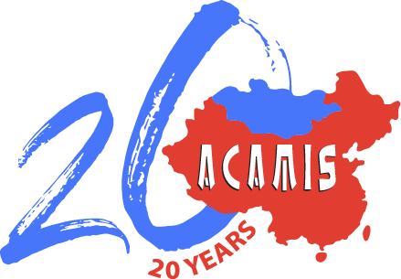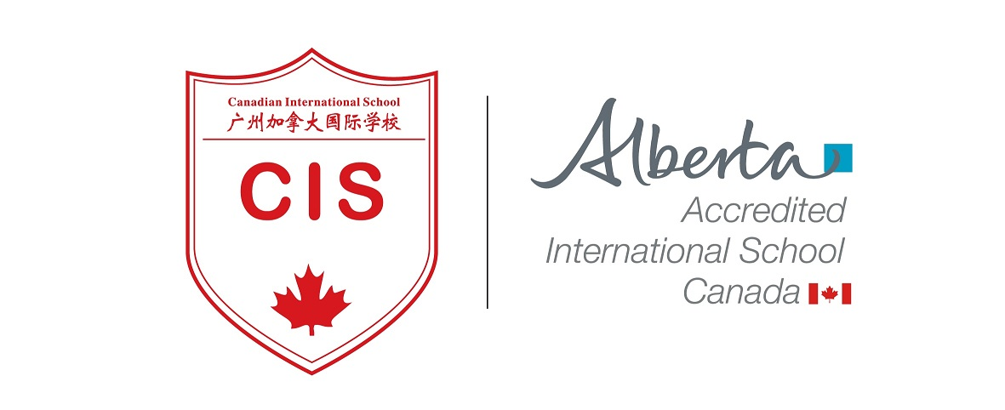

2020 ACAMIS Chinese Conference
June 27-28, 2020
Canadian International School of Guangzhou
君子：论道，行之 Junzi : On Knowing and Doing

Presenting at the ACAMIS Chinese Conference is a great way to share your knowledge and expertise with your fellow teachers. It is also an excellent opportunity for networking.

君子是中国人推崇的理想人格典范，作为国际学校的中文老师，许多老师以此提醒和激励自己。在社会急遽发展的今天, 中文老师们常常面对各种教学理念的冲击和多元化教学方法的挑战，还要应对来自各方的压力，有时会四顾茫然，踯躅不前。因此，越是在这样的时刻，我们应该回到教育的本质，回顾我们选择国际中文教师的初衷，探求中文教师在国际学校的使命和责任。

2020 ACAMIS 中文大会除了“坐而论道”，我们更要做到“知行合一”。因此, 我们也将邀请一线优秀教师为大家讲解最有效的教学方法、分享最成功的教学实践和展示最有情怀的课堂体验。

This year’s ACAMIS Chinese conference is going to focus on reflecting and applying Junzi’s philosophy into our lives and classroom learning. Junzi's character and philosophy is highly appreciated and valued in the traditional Chinese community. Chinese teachers often reflect on his teachings and motivate themselves to be better educators. In today's rapidly changing world, as Chinese teachers, we face with an increasingly diverse teaching concepts and methods, along with challenges and pressures that we sometimes feel bewildered and confused. This conference provides an opportunity to rethink the true meaning of education and our role as Chinese teachers in the international school settings, and the mission and responsibility as a Chinese teacher.

We are looking for teachers with ideas and strategies to share at our conference. If you already practice good collaboration with a teacher, you can come and present together. If you have tried different strategies in the classroom that have been successful, come share them with your colleagues.

We are looking for strategies takeaways that are relevant to the theme. We welcome teacher presenter teams to share their expertise with our peers. Possible examples might include (but are not limited to):
- Effective teaching strategies/methods
- Using technology to teach Chinese language and culture
- Curriculum design and implementation (especially for early childhood education (ECE)/kindergarten and elementary/primary years*)
- Assessment for learning
- Integrating language with culture
- Classroom management
- Chinese teachers’ professional development/growth
- Other pedagogies such as:
  - Mother-tongue 母语
  - Bilingual Learning 二语
  - Near Native 近母语
  - Differentiated Instruction 差异化教学

*newly added

Presentations session should take no longer than 75 minutes. We will review all proposals and let you know our decision.

If you would like to submit more than one proposal, please submit a separate proposal form.

Deadline for Proposal Submissions
Please send the Teacher Presentation Proposal Form to eo@acamis.org before Friday, February 28, 2020. We will review and the proposals and notify you of the decision on selection. If necessary, we will contact you to schedule a video call for more information. Upon confirmation of approval, we will follow up with registration where approval peer presenters will enjoy a 25% reduced rate on the conference registration fee.

NOTES:
- Your proposal must be approved by your Head of Department and Head of School.
- The presentation should preferably be rehearsed among departmental colleagues for quality assurance.
- You agree to provide soft copies of presentation materials (for example the PowerPoint slides) to participants.
- Presenters selected will receive a 25% discount on the conference registration fee.
- If your proposal is approved by the committee, the contents of this form will be posted on the ACAMIS website and on the Guidebook app that will be seen by participants.

Thank you for stepping up to this challenge!
We look forward to receiving your proposal!

Emily Liao, Canadian International School of Guangzhou
Peter Guo, Keystone Academy
Mary Yu, Yew Chung International School of Shanghai, Pudong Campus
Dan Zhu, Beijing City International School
Ruya Brunton, Shanghai United International School
ACAMIS Chinese Language Teachers Network (CLTN) Planning Committee

(Please scroll further down to the Proposal Form)

2020 ACAMIS Chinese Conference
Teacher Presenter Proposal Form
*Please feel free to complete this form in Chinese if you prefer*

Photograph of Presenter (high res photo, image can be sent separately)

Name:
Email Address:
School Name:
Grade Level  *Please bold/highlight your choice(s) | Early Childhood  Primary  Secondary
Role/Position:
A short profile/bio/description about yourself (no more than 100 words):
Presentation Title:
Short description of your workshop proposal:
How will your workshop it connects to our theme?

Target Audience(s):
Who will benefit from your presentation? (e.g. Target age groups/grade level and language proficiency level):
Please bold/highlight appropriate category(ies) of your presentation, or specify if necessary: | - Effective teaching strategies/methods  - Using technology to teach Chinese language and culture  - Curriculum design and implementation  - Assessment for learning  - Integrating language with culture  - Classroom management  - Chinese teachers’ professional development/growth  - Other pedagogies such as:  - Mother-tongue 母语  - Bilingual Learning 二语  - Near Native 近母语  - Differentiated Instruction 差异化教学  Others – please specify here:
What would be the ‘take-away’ for the audience?
What would you require for your presentation?
- Powerpoint format - for Windows or Mac?
- Do you need Audio/Video set up?
- Do you need stationery (markers, chart papers, etc.)? Please clearly specify the items and quantities.
- Please specify other classroom set up needs if any.

Thank you for your submission. We will contact you with our decision.

